# PROJECT TWO README: DOG SEARCH RESCUE AND TRAINING

## Dog Search and Rescue Application

This application is to assist the client, Grazioso Salvare, an international rescue-animal training company in identifying and categorizing dogs for their search and rescue training. Using the data from five animal shelters in Austin, Texas, the application streamlines the process of selecting dogs that meet specific criteria for various types of rescue operations such as water rescue, wilderness rescue, disaster response, and scent tracking. This application is easy to use interface with the ability to filter through the database depending on what type of rescue animal they are looking for.

This application uses MongoDB to store and manage the animal shelter database. MongoDB is a noSQL model so it has a flexible schema design that allows for easy storage of various data types and structures. It uses python for integration – ‘pymongo’ library. This library facilitates CRUD operations and querying. To create an interactive web application, Dash framework is used. It has the ability to create dashboards using python, and it integrates with Plotly for data visualizations. It has built-in support for callbacks and this allows for efficient handling of user interactions.

This application uses the CRUD operations (create, read, update, and delete) for managing animal data. It has the ability to create a new document, read/query data, update data, and delete a data. All of these functionalities are crucial to make the Dog Search and Rescue Application.

## Motivation

The client’s mission to save lives through the use of search and rescue dogs motivated the creation of this project. The application strives to improve the efficiency of identifying suitable dogs for training. This enhances the company’s ability to prepare dogs for life-saving operations. Per the client’s request, this application will be open-source so other organizations who have similar goals can benefit and contribute to the ongoing development of the tool.

## Getting Started

Set up the MongoDB database by importing the necessary data set.

Create a user account to have the ability to access and make updates to the data set.

## Installation

Install the necessary tools such as MongoDB, python, and Jupiter.

## Usage

Please see steps and screenshots below for instructions/examples of how to use the Dog Search and Rescue Application.

### Code

After setting up an account and the CRUD python module, create the python code for the dashboard.

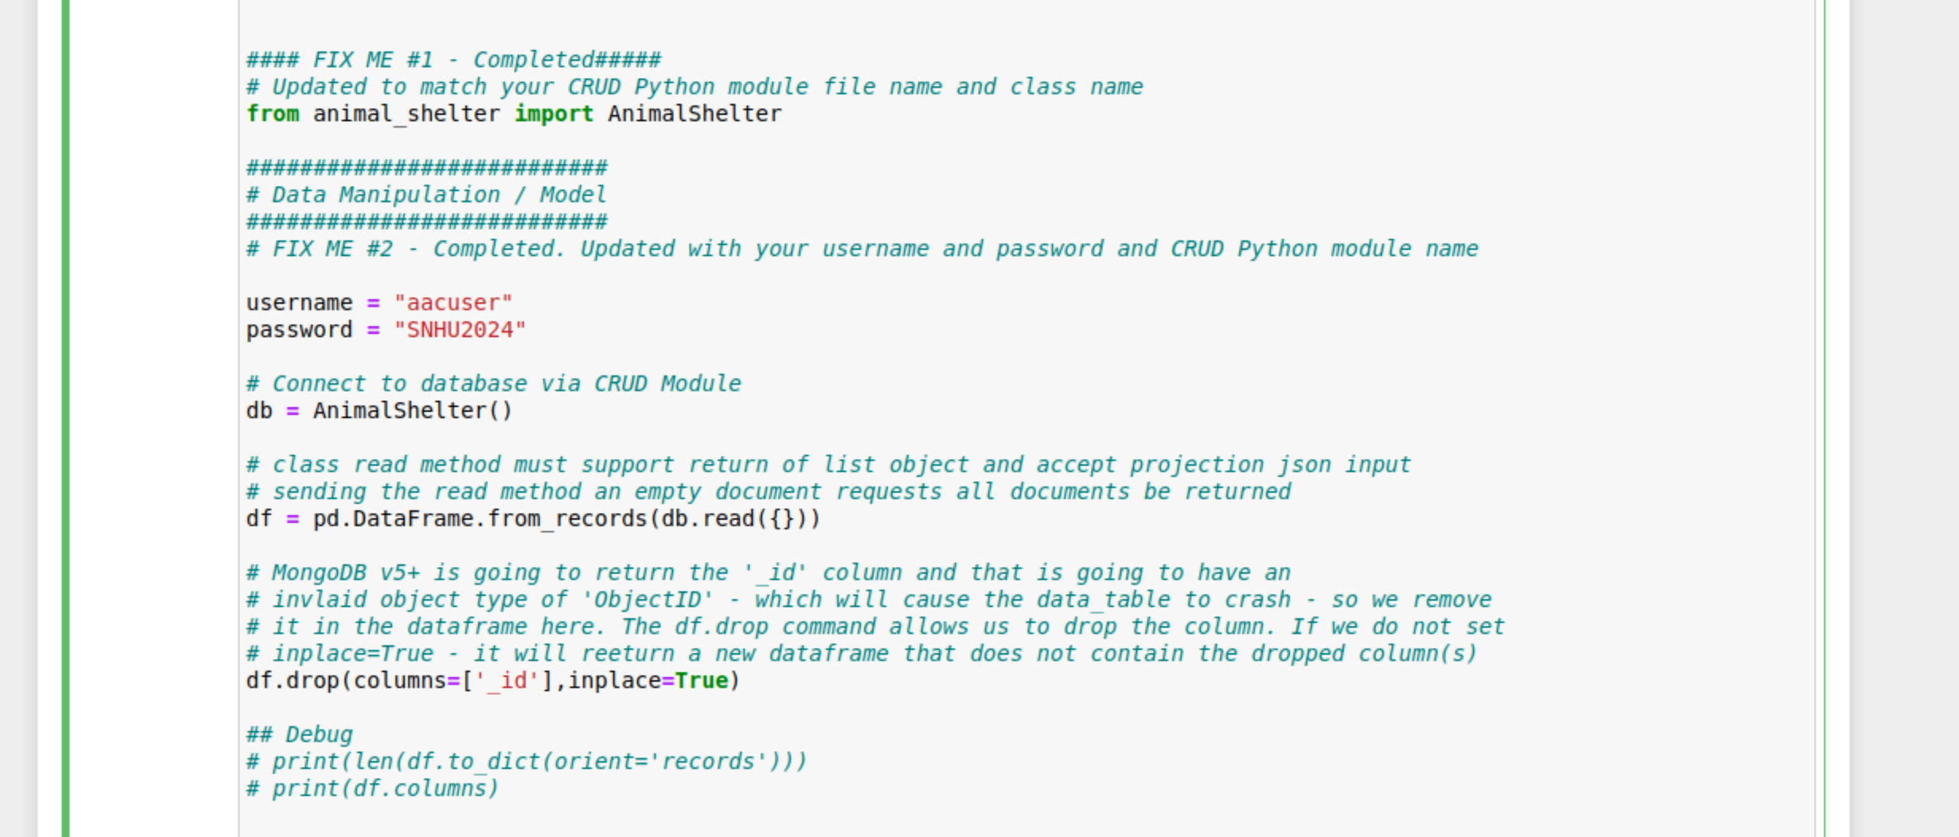

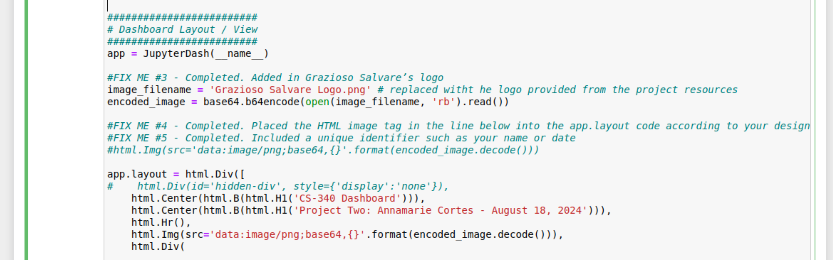

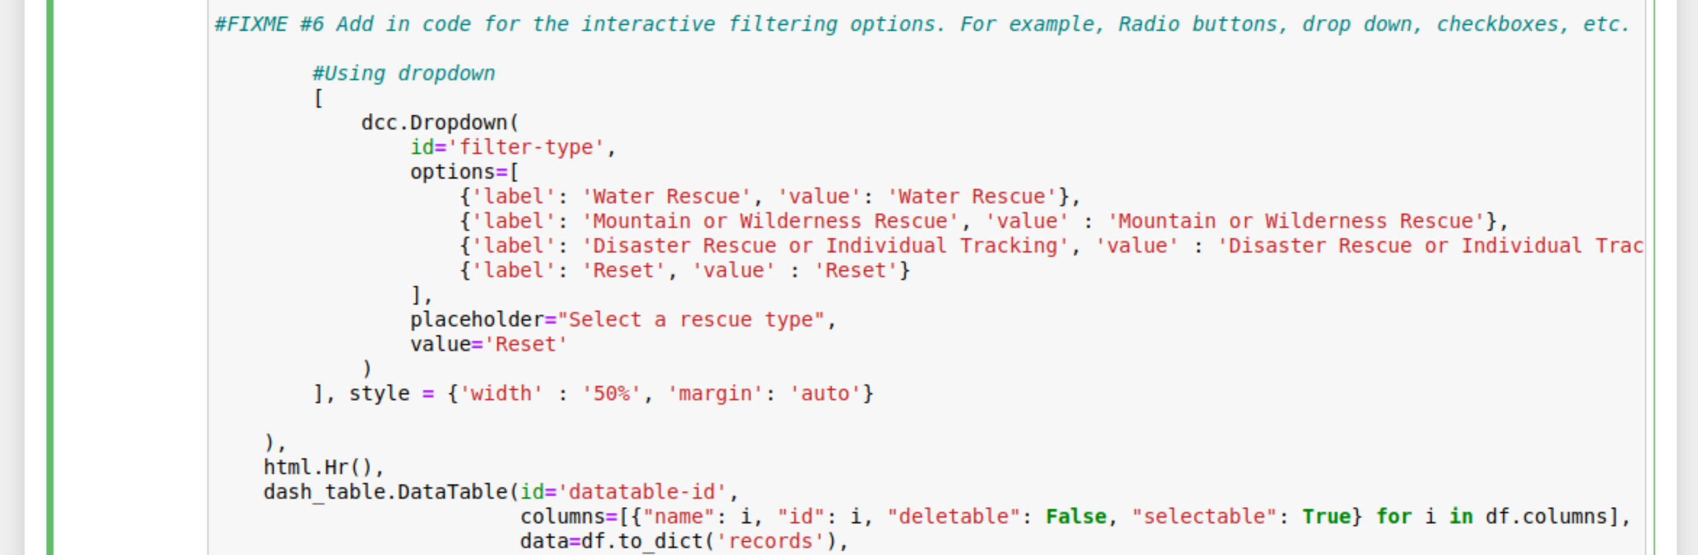

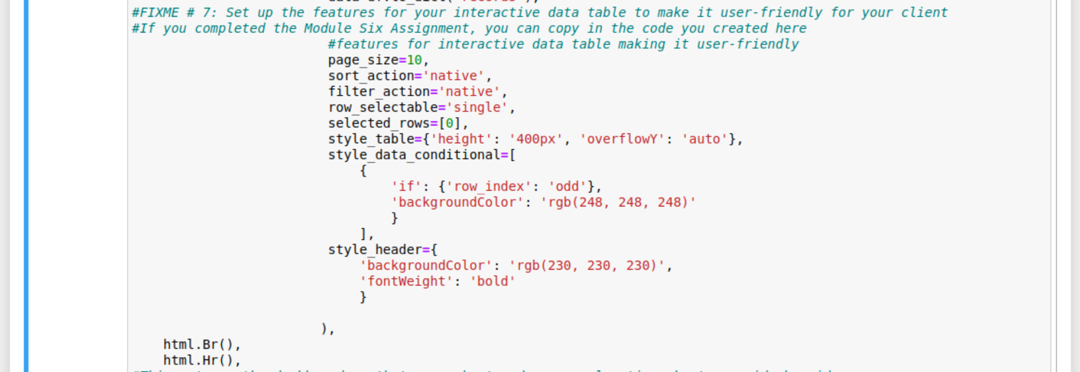

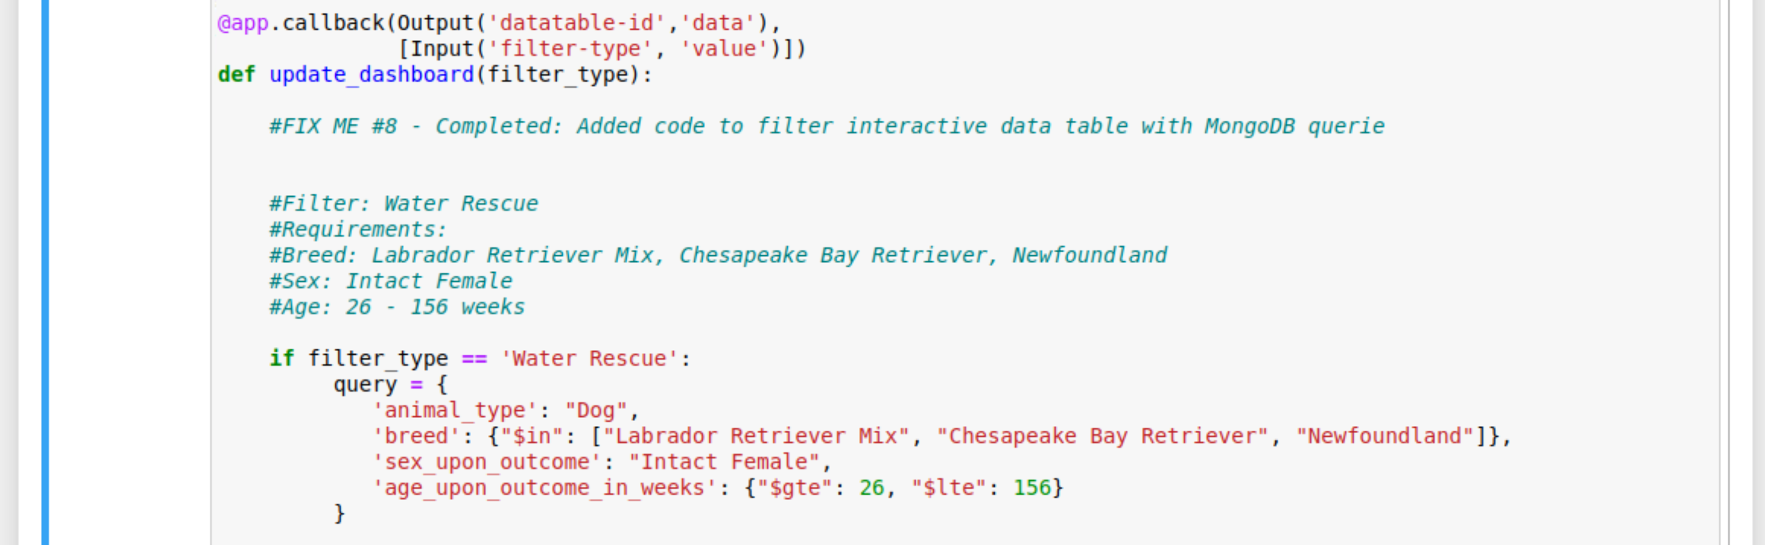

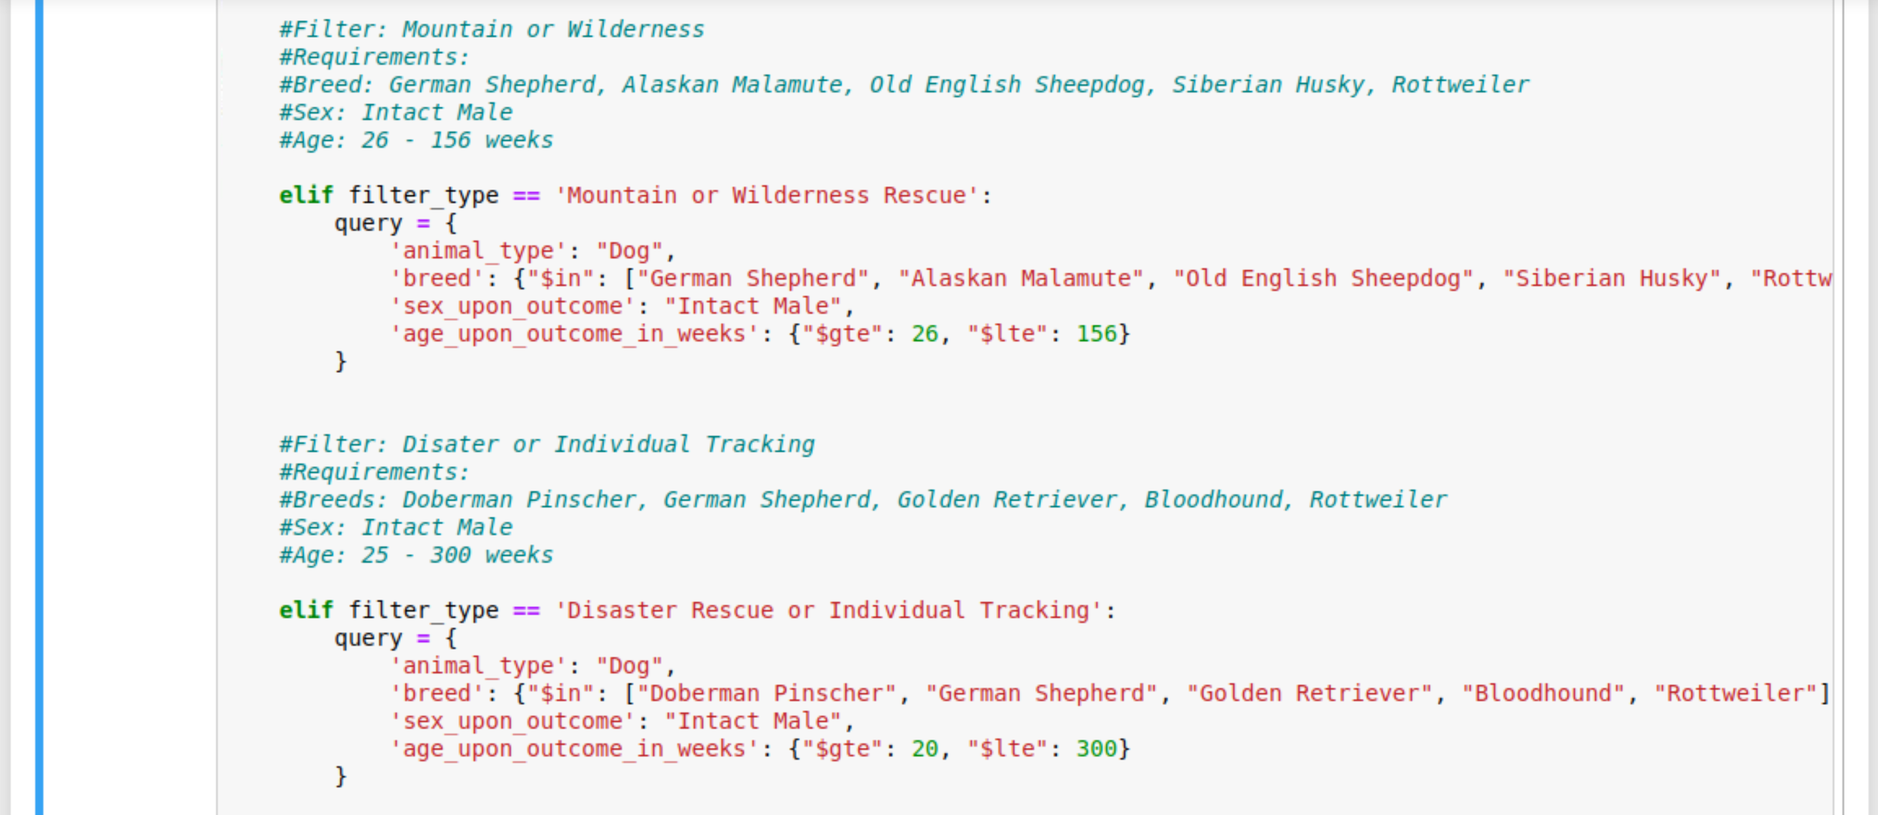

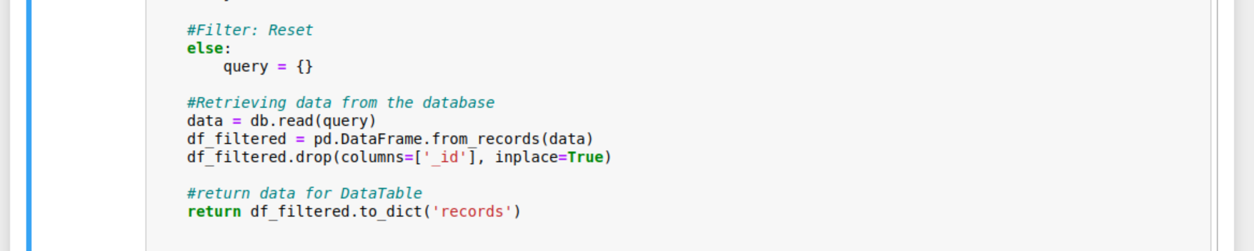

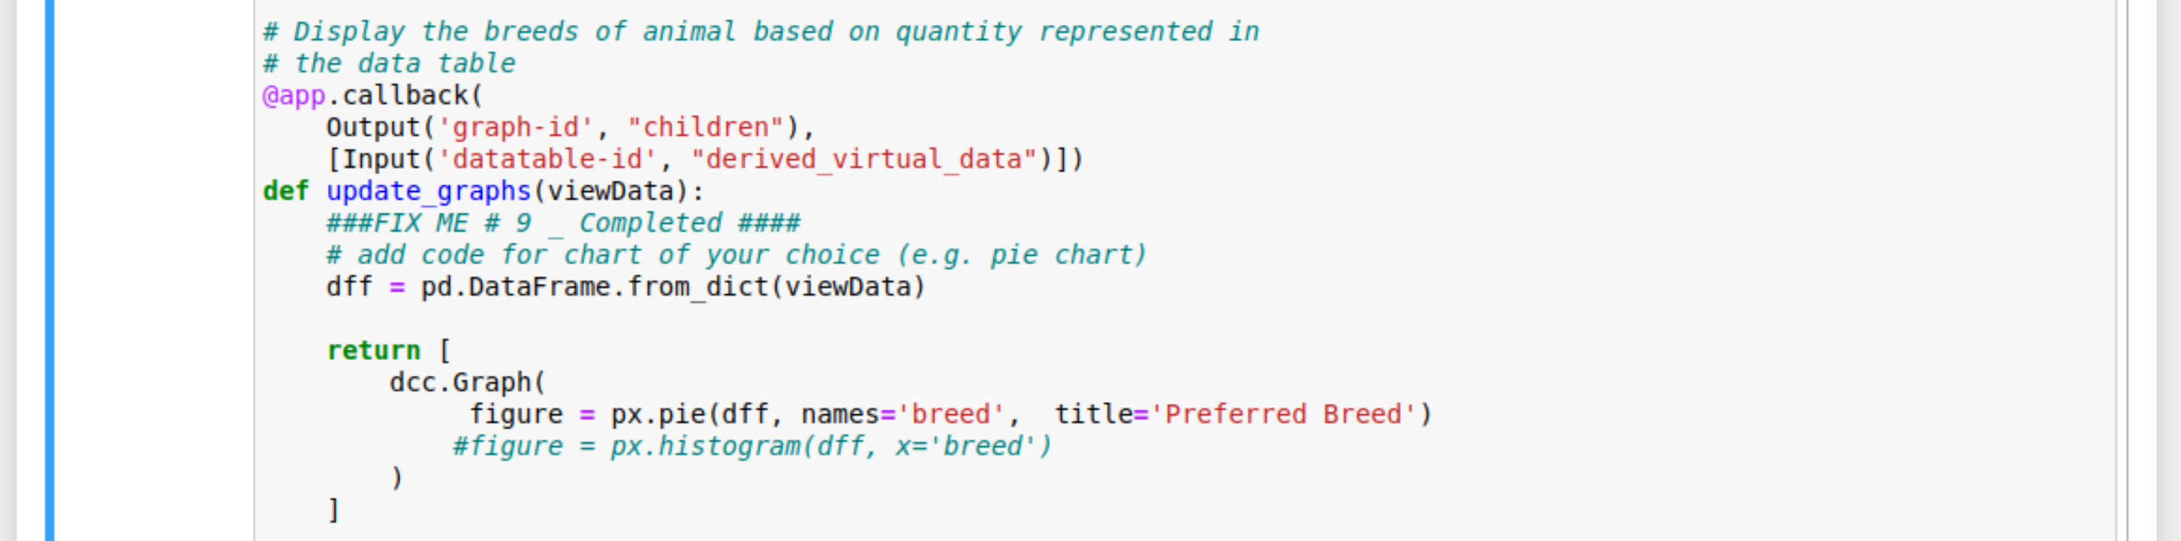

**Test/Running Dash**

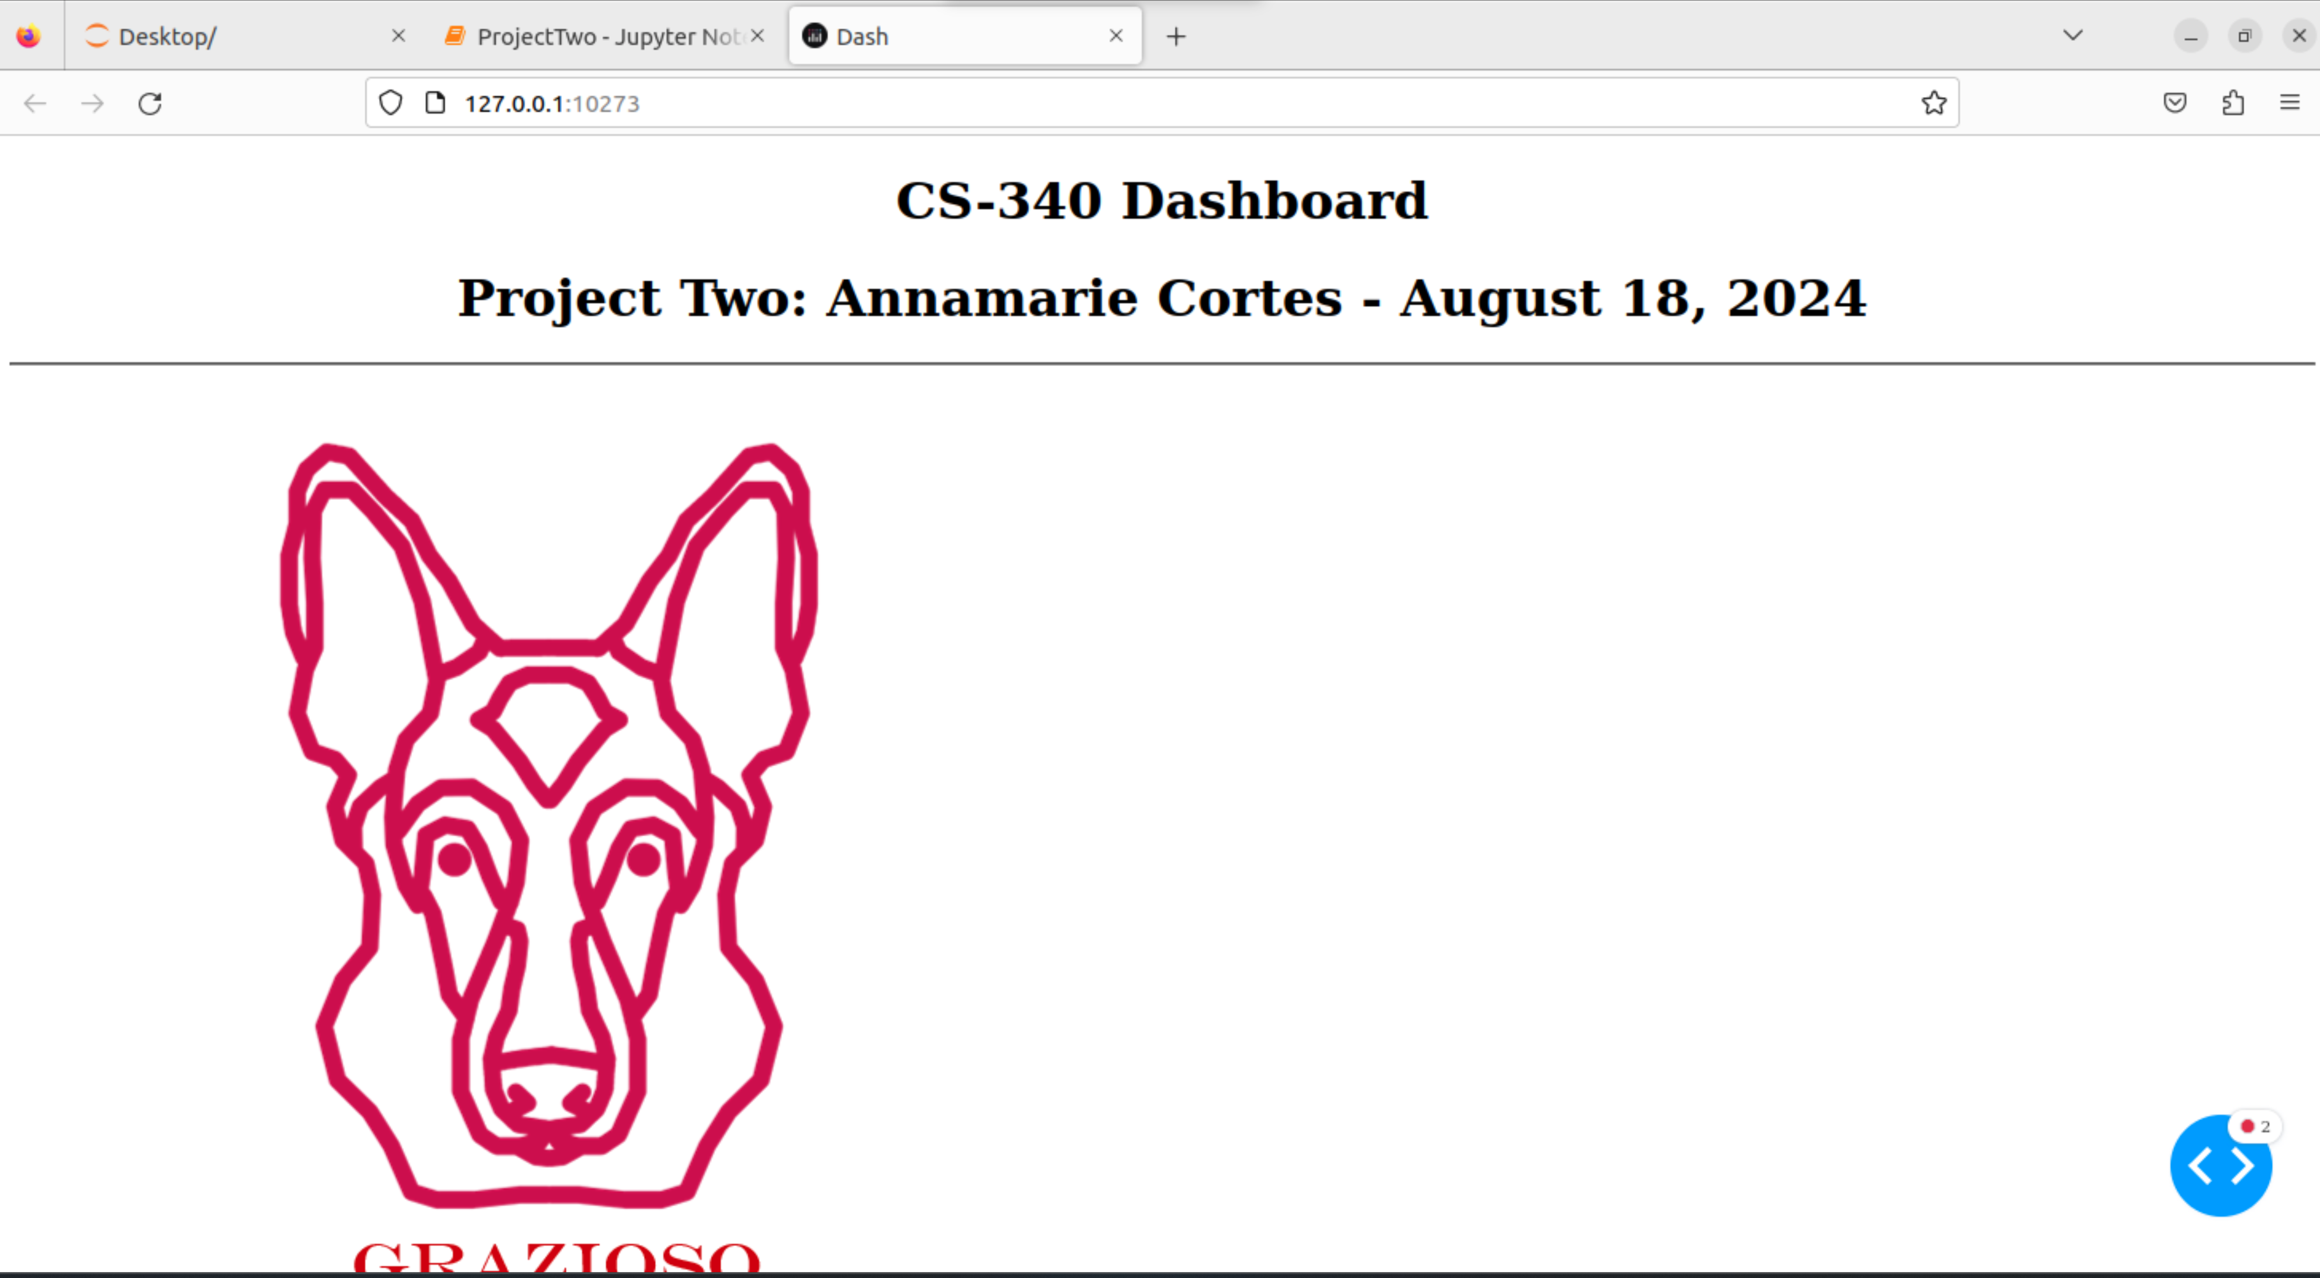

Dropdown Menu

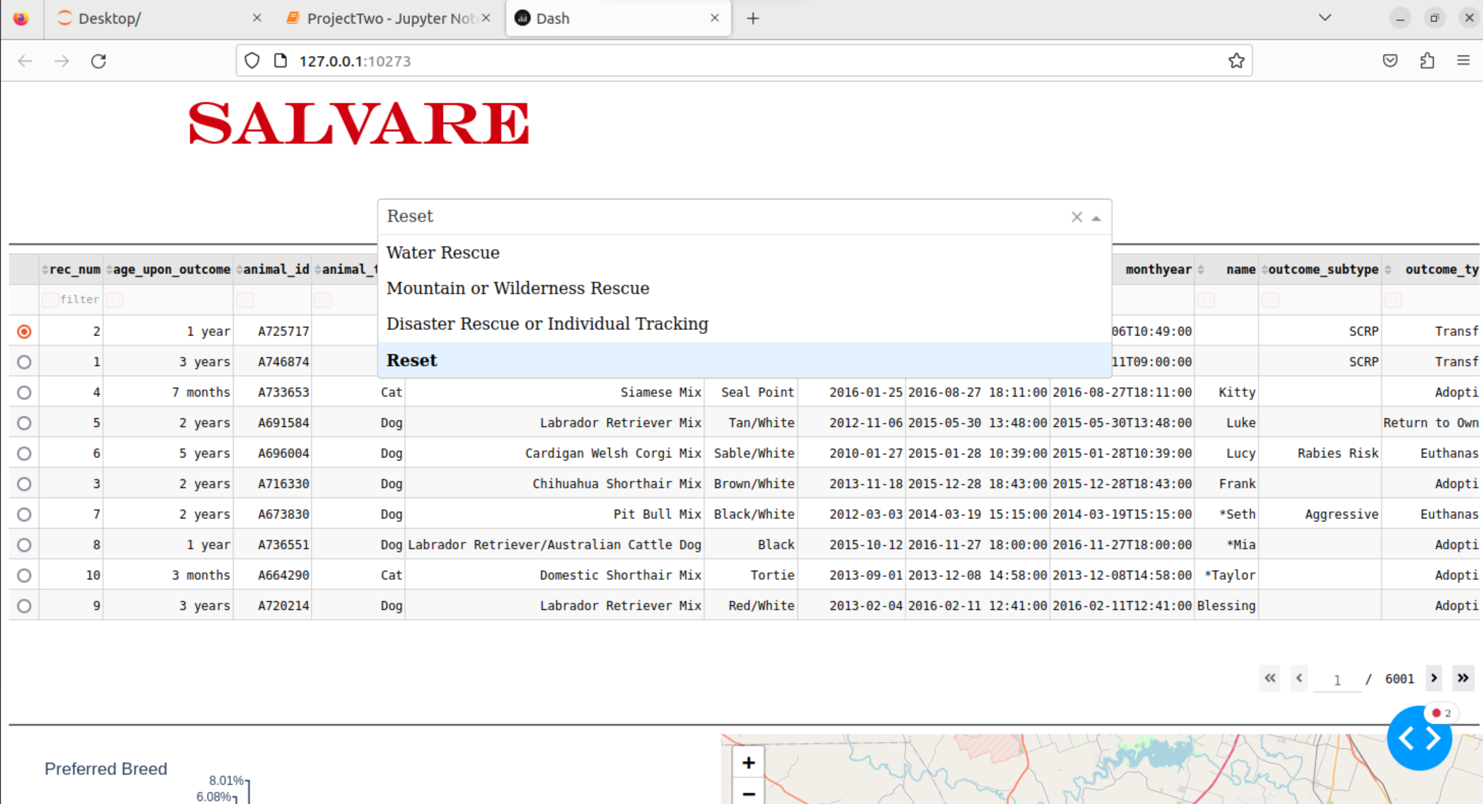

Reset/Unfitered View

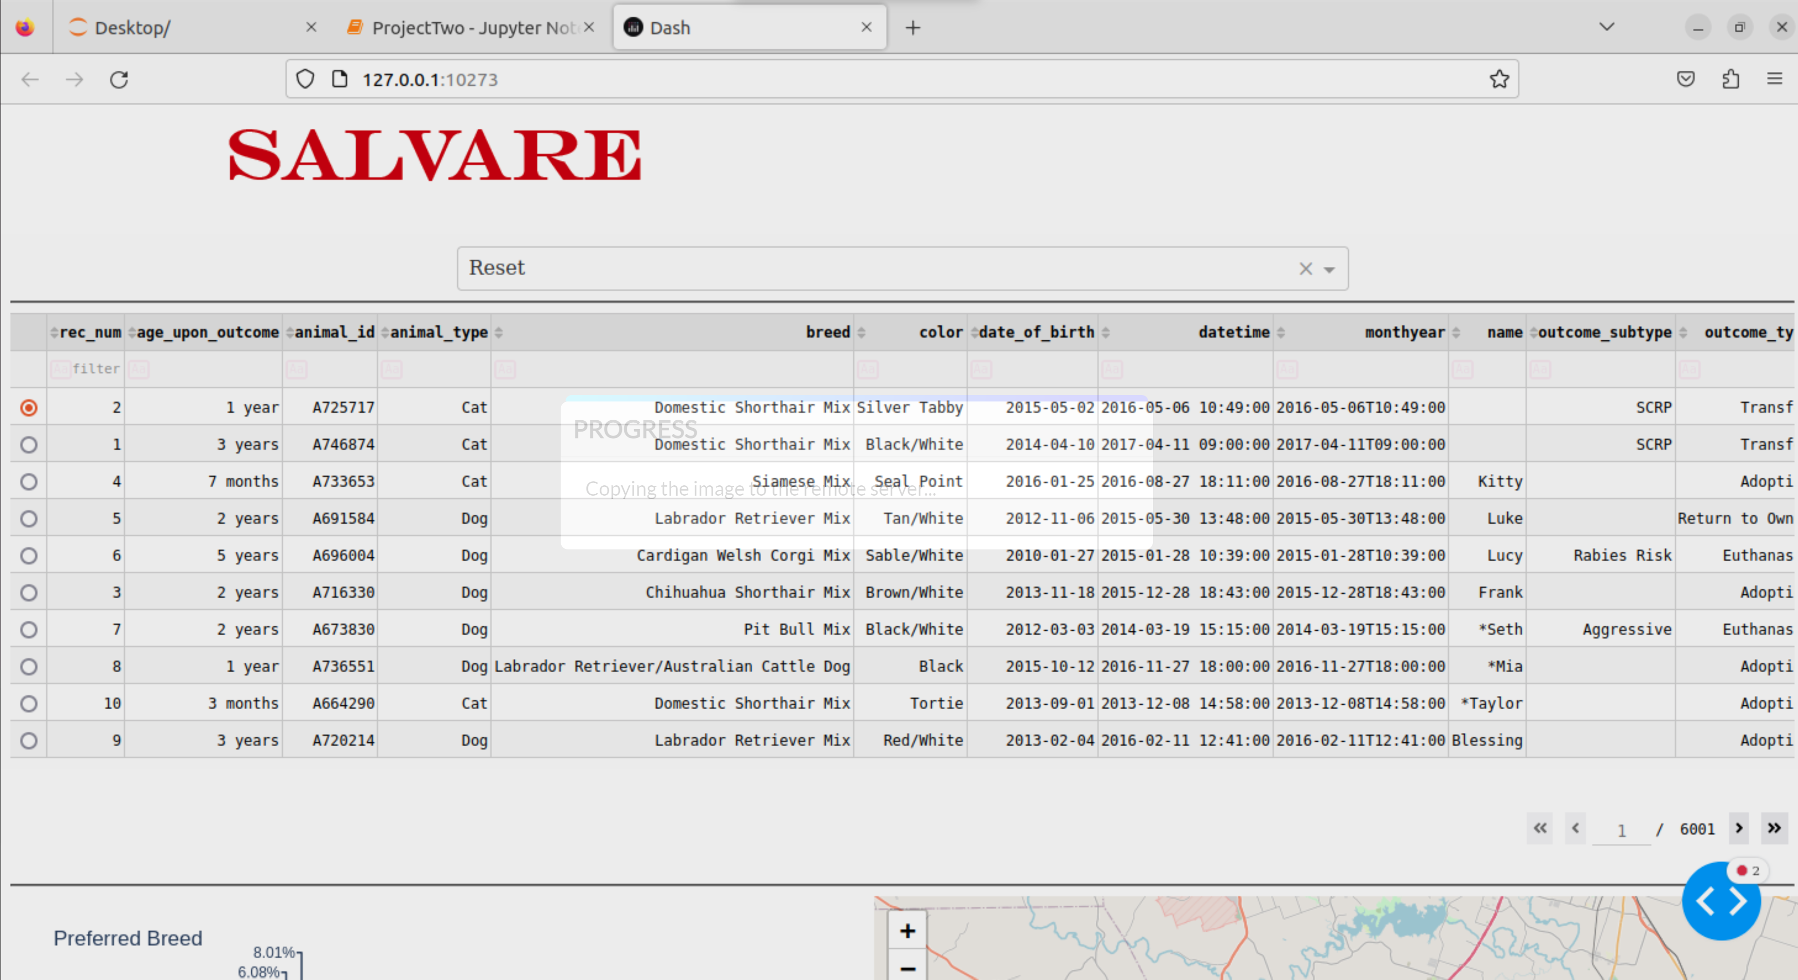

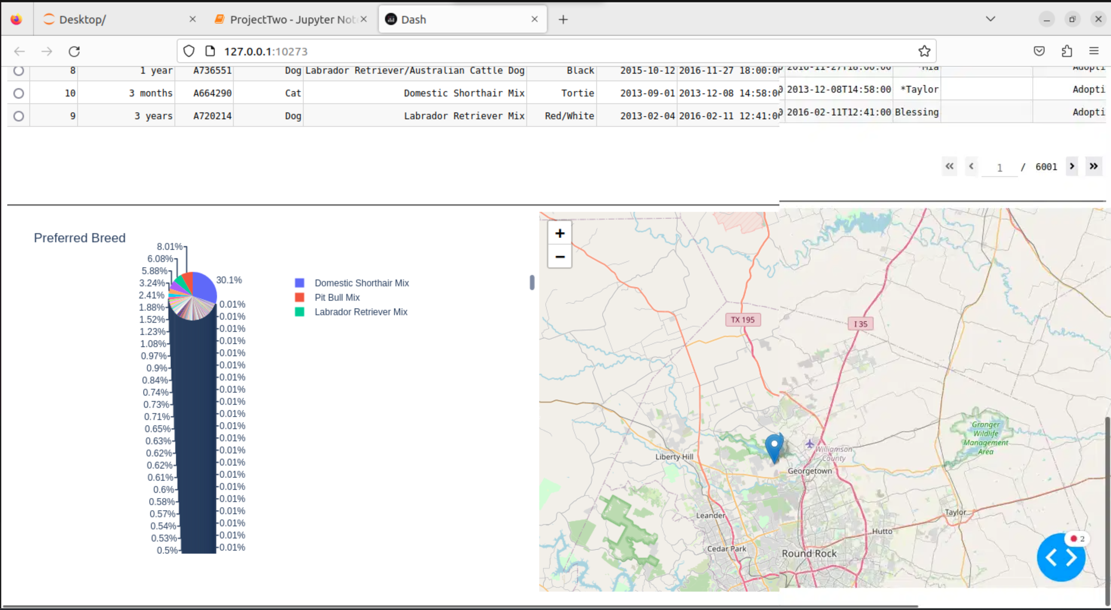

Water Rescue Filter

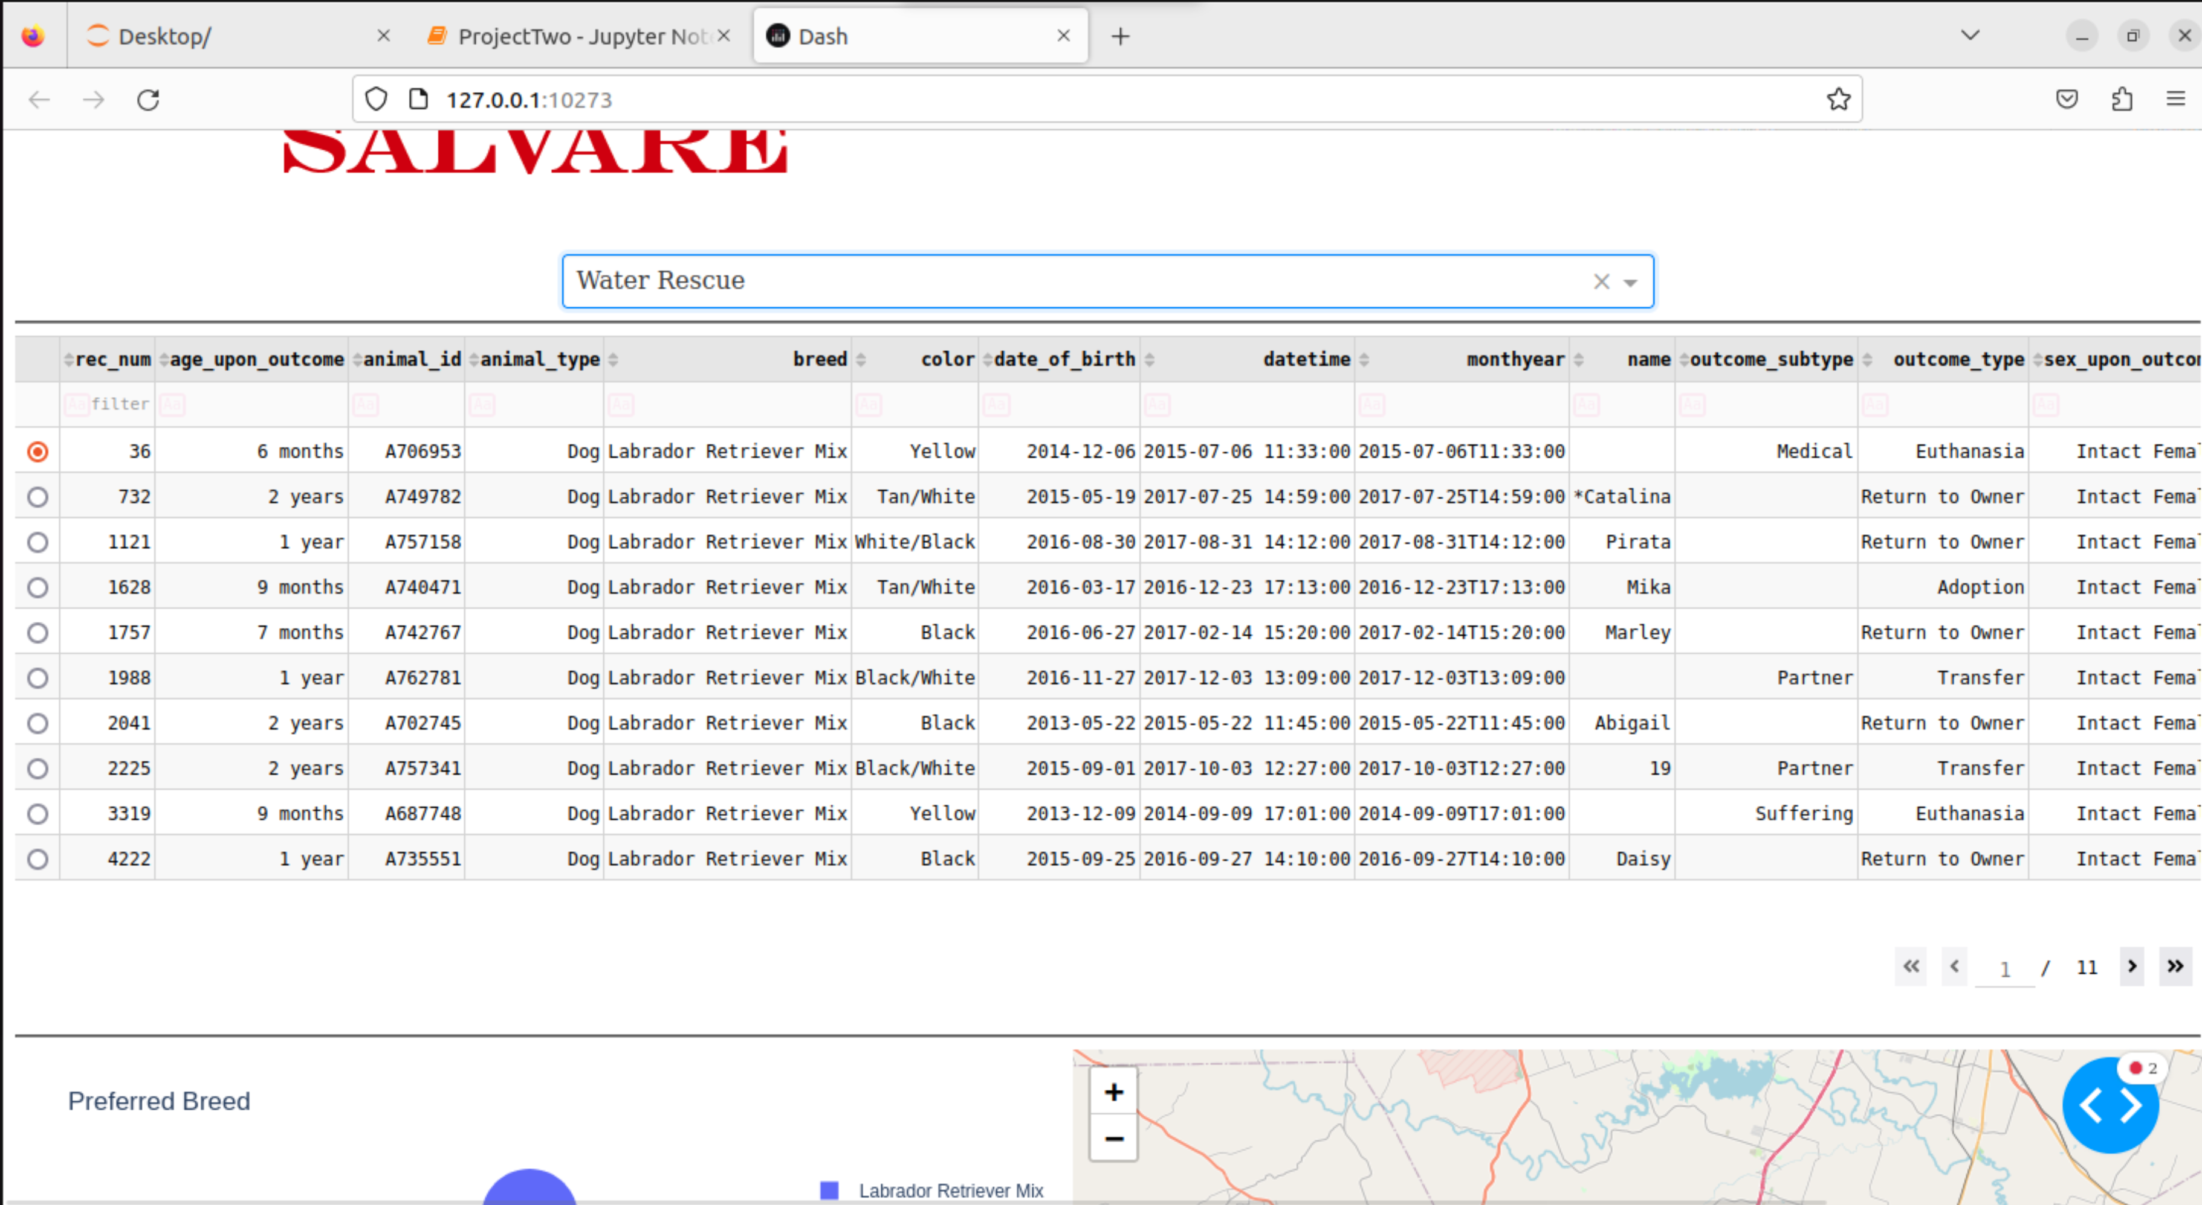

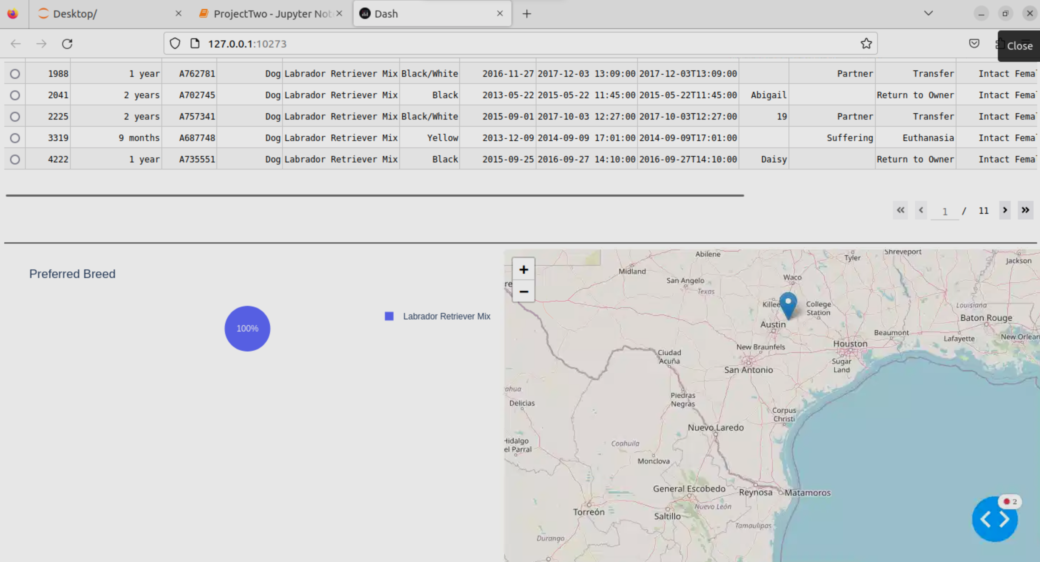

Mountain or Wilderness Rescue Filter

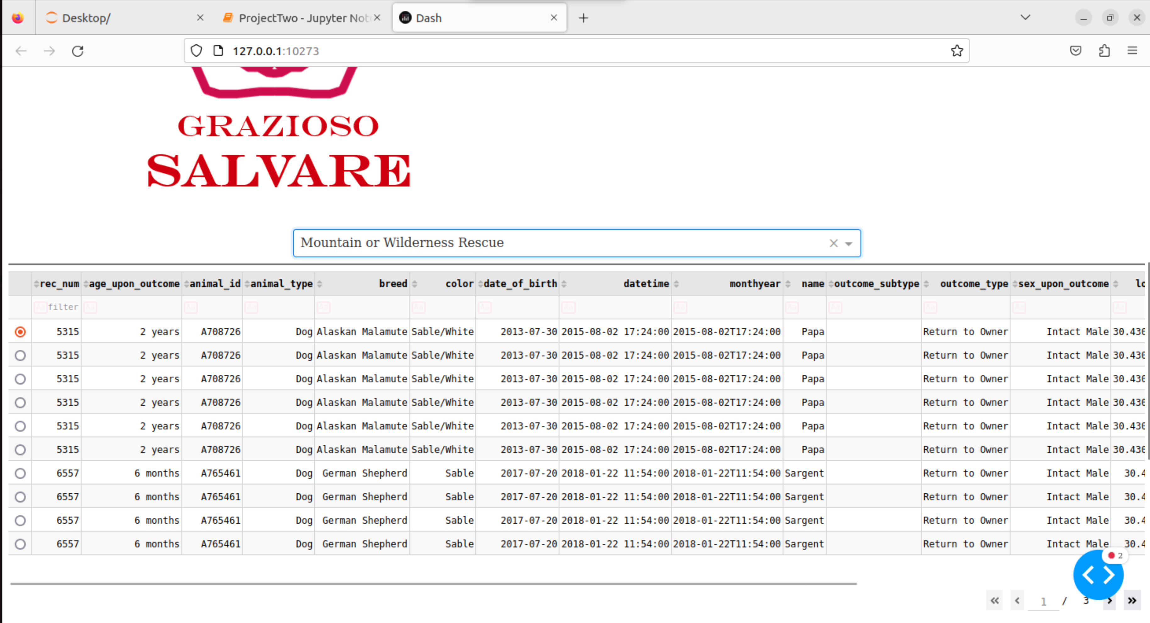

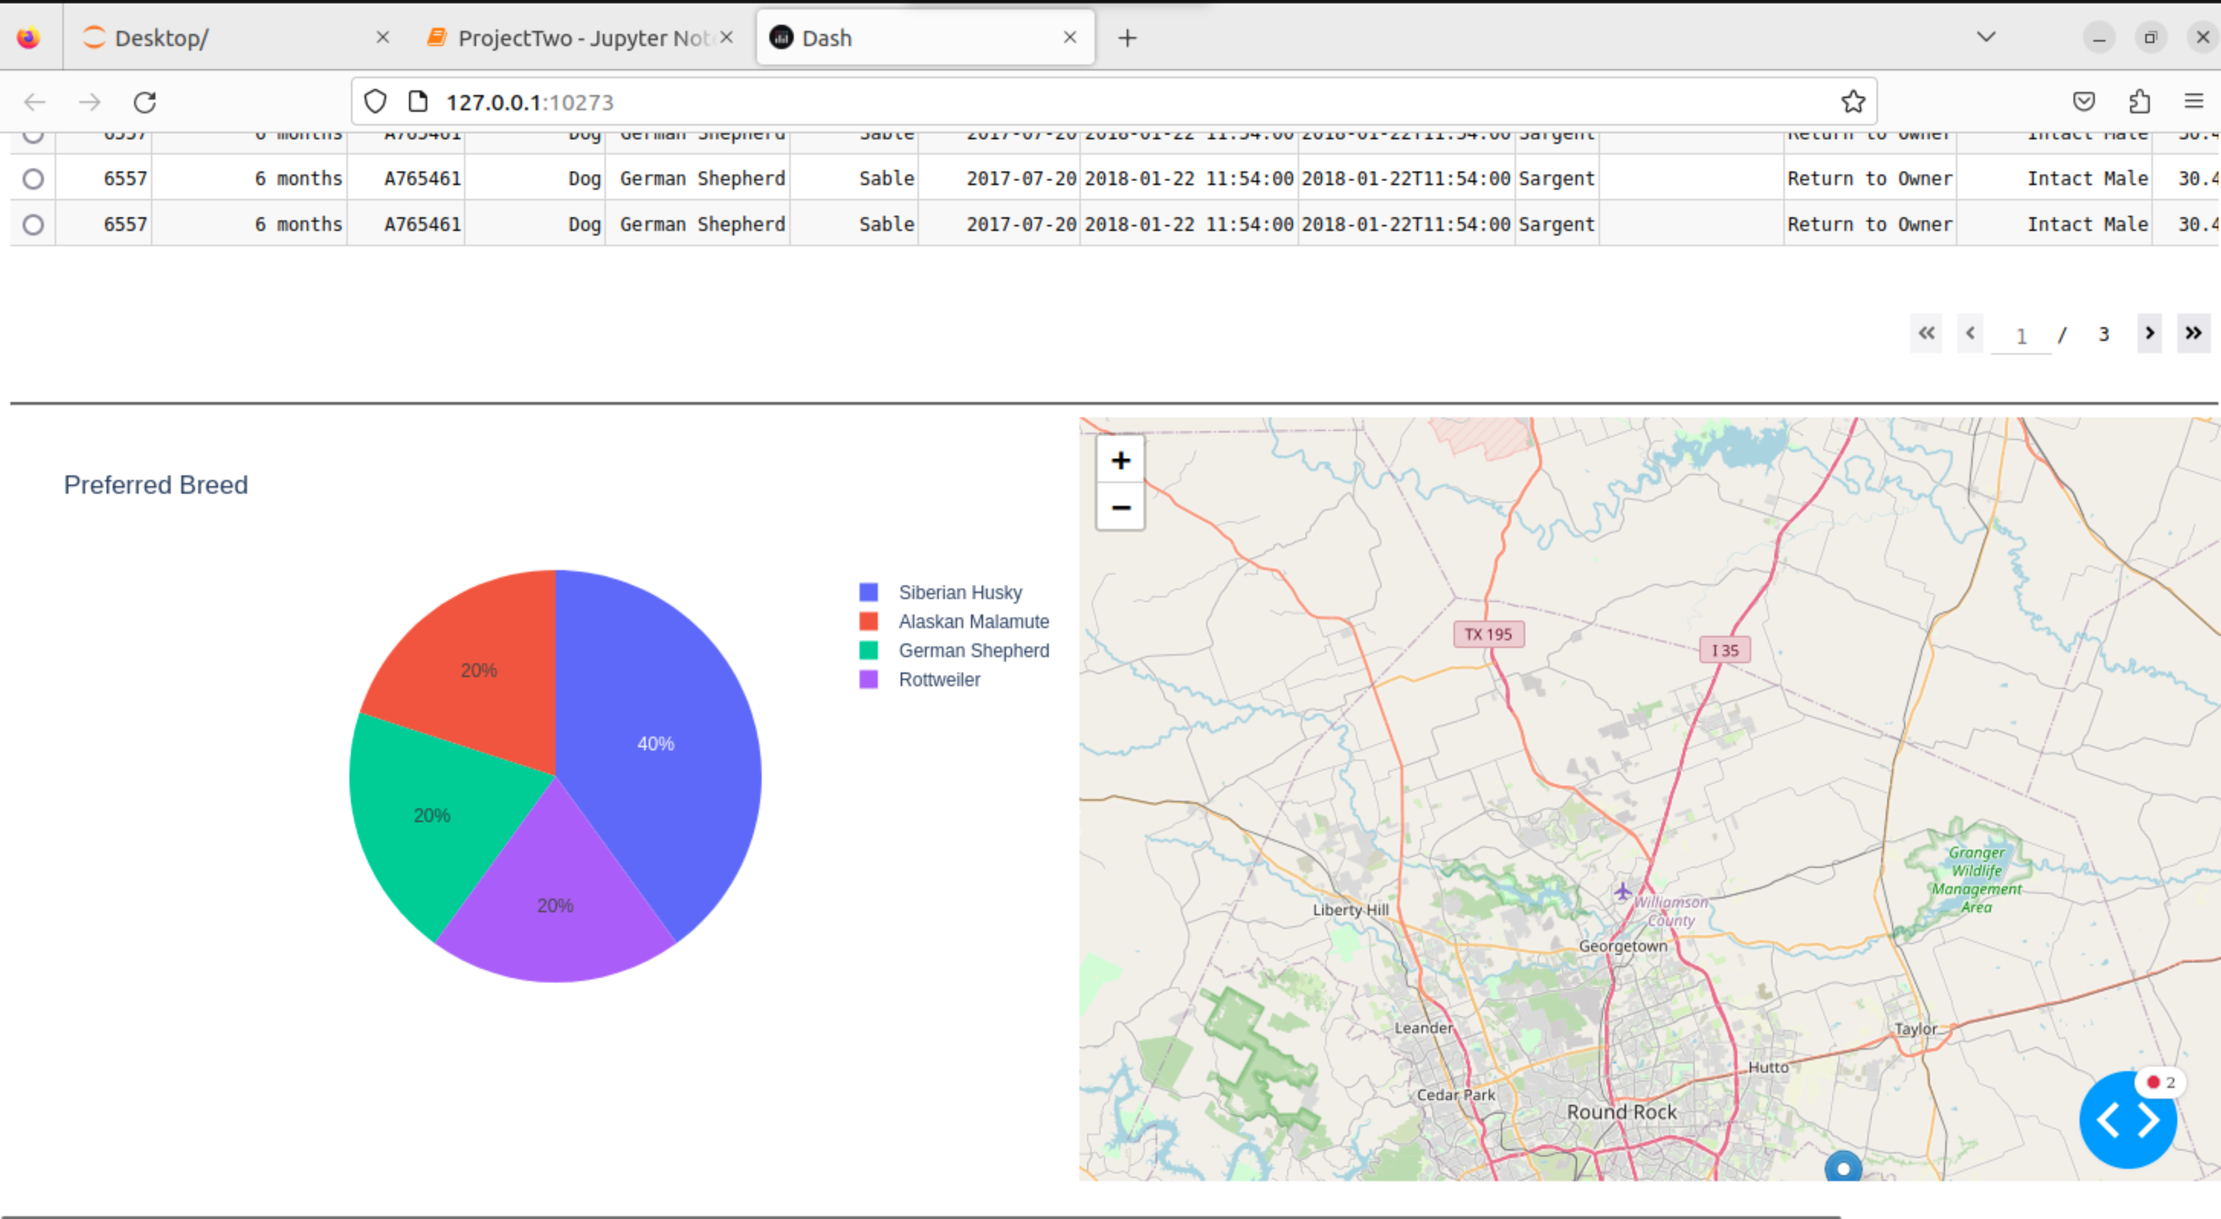

Disaster Rescue or Individual Tracking

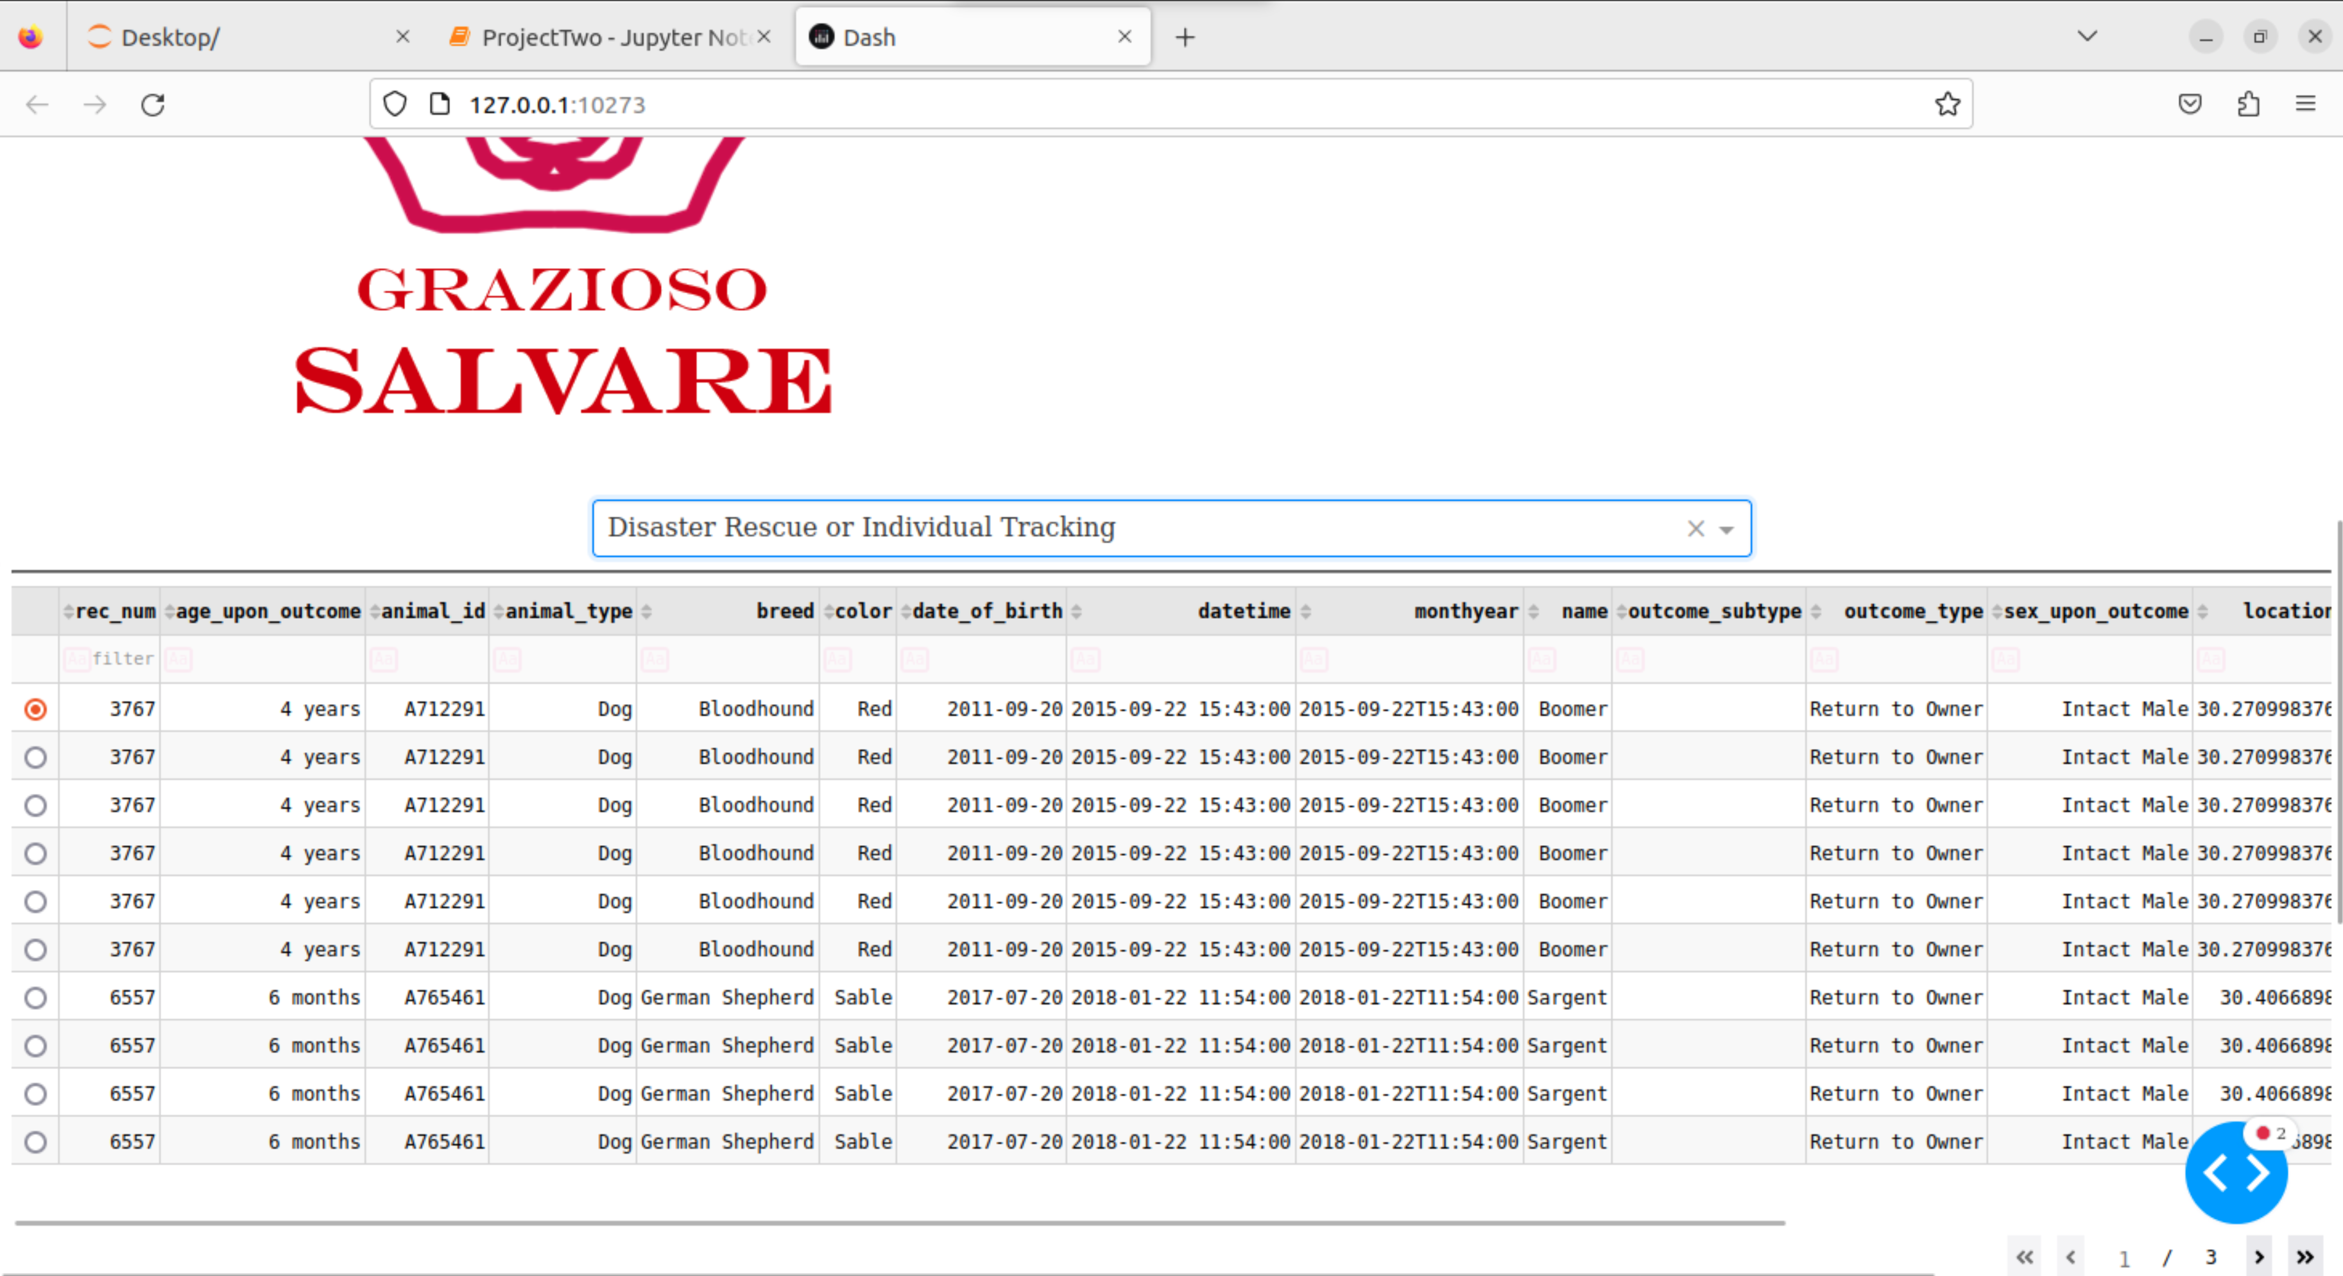

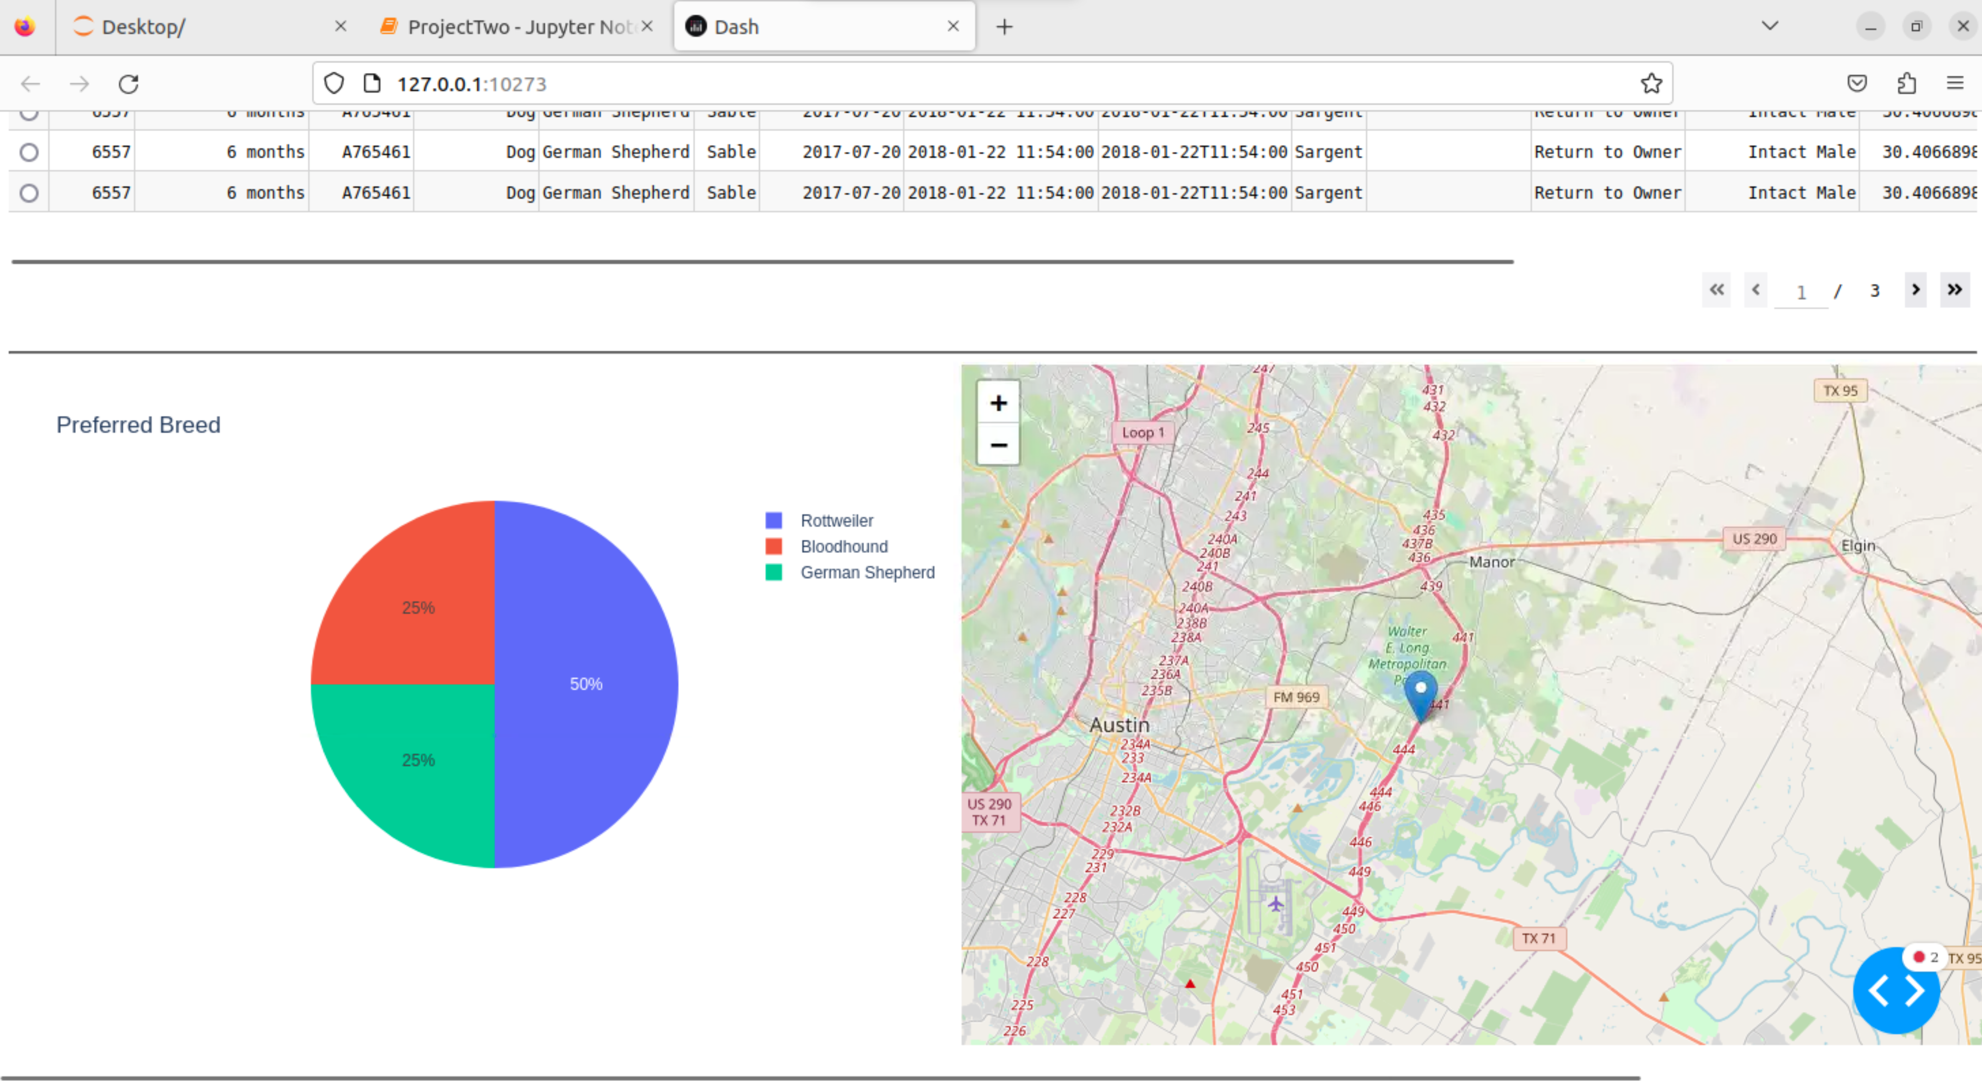

Challenges

I encountered several challenges in this project. One major issue was ensuing that filters were applied correctly to the data and that changes were accurately reflected in the visualizations. This was addressed by debugging and validating the query construction and data manipulation steps, using print statement to check the query results.

Another challenge that I encountered was ensuring that the pie chart visualization accurately reflected the filtered data and updated dynamically. Initially, it would not refresh when a new filter was selected. I debugged the issue and tried different chart such as a bar chart just to try different things and see where the error was occurring.

Resources and Links:

Dash Documentation: <https://dash.plotly.com/dash-core-components>, <https://dash.plotly.com/datatable>

MongoDB documentation : <https://www.mongodb.com/docs/>

## Contact

Your name: Annamarie Cortes